Software Engineering Lab Experiments
Laboratory Manual

Name : K Sujith Sai Vighnesh
Register Number: 192311199
Department : CSE
Course : CSA1017
Faculty : Dr. Latha R

SAVEETHA SCHOOL OF ENGINEERING

EXPERIMENT NO. 14

Git/GitHub Collaborative Development Using Fork and Pull Request Workflow

Aim
To demonstrate collaborative software development using Git and GitHub through the Fork and Pull Request workflow.

Software Requirements
- Windows 10/11 (or Linux/macOS)
- Git
- GitHub Account
- Visual Studio Code (or any code editor)
- Web Browser
- Internet Connection

Theory
Git is a version control system used to track changes in source code. GitHub is an online platform that hosts Git repositories and enables collaboration among developers. The Fork and Pull Request workflow allows developers to contribute to a project without directly modifying the original repository. A developer first creates a fork of the repository, makes changes in a separate branch, commits and pushes those changes, and then creates a Pull Request for review. After the changes are reviewed and approved, they are merged into the main branch. This workflow helps maintain code quality, supports teamwork, and keeps the project organized.

Procedure
Step 1: Fork the Repository
- Open GitHub.
- Select any public repository.
- Click the Fork button.
- Wait for GitHub to create a copy under your account.
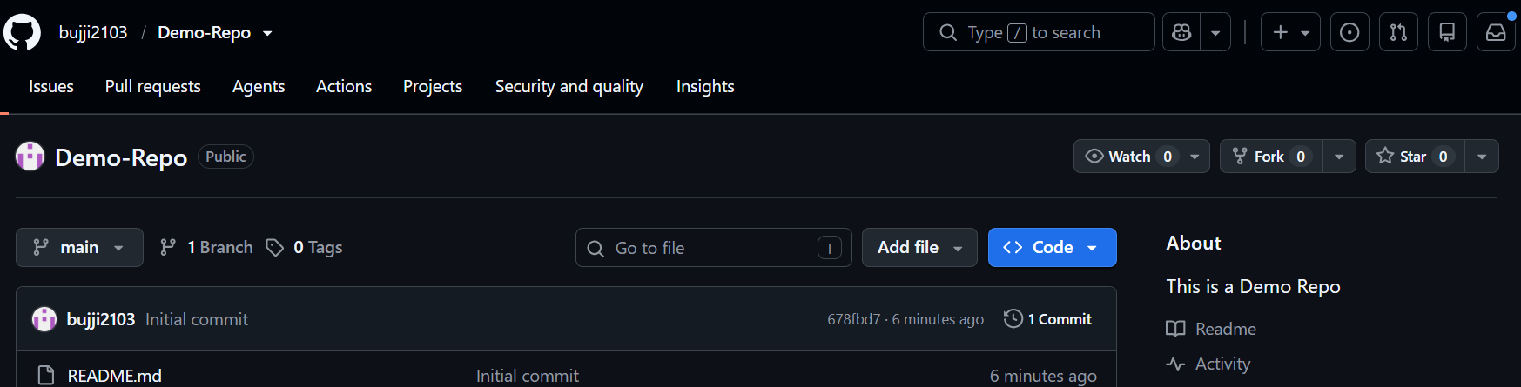
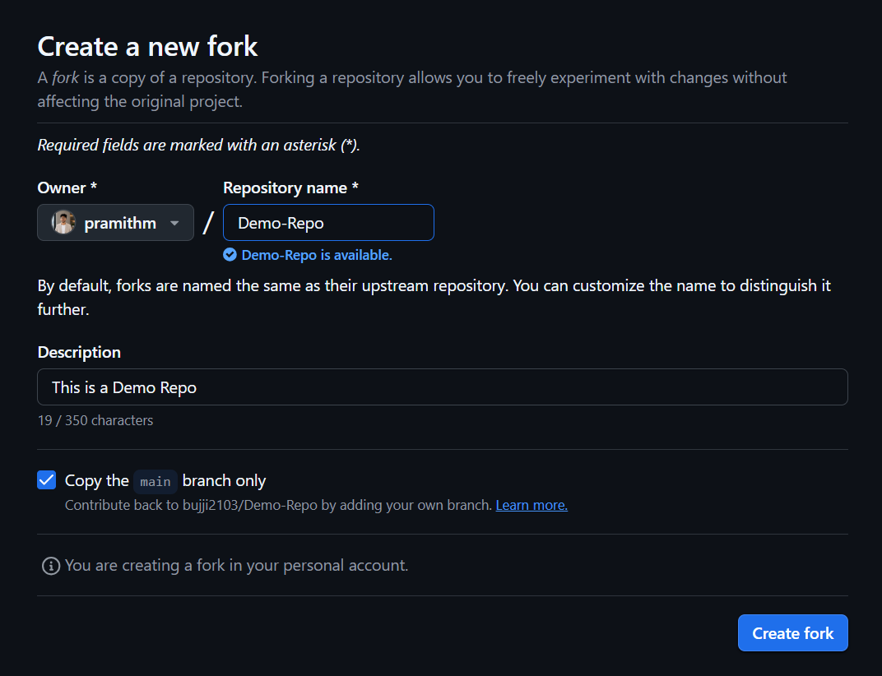
Step 2: Clone the Repository
Open Git Bash or Terminal.
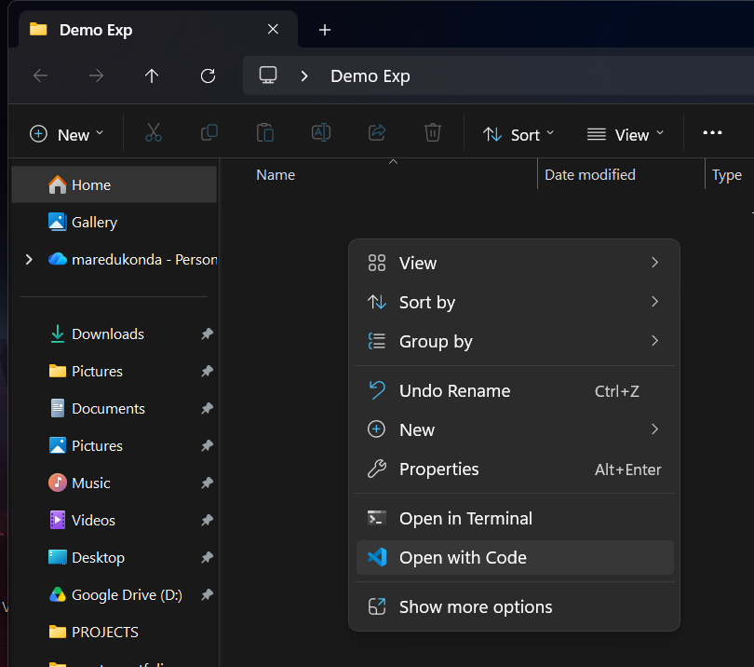
git clone https://github.com/YourUsername/RepositoryName.git

Move to the project folder.
cd RepositoryName
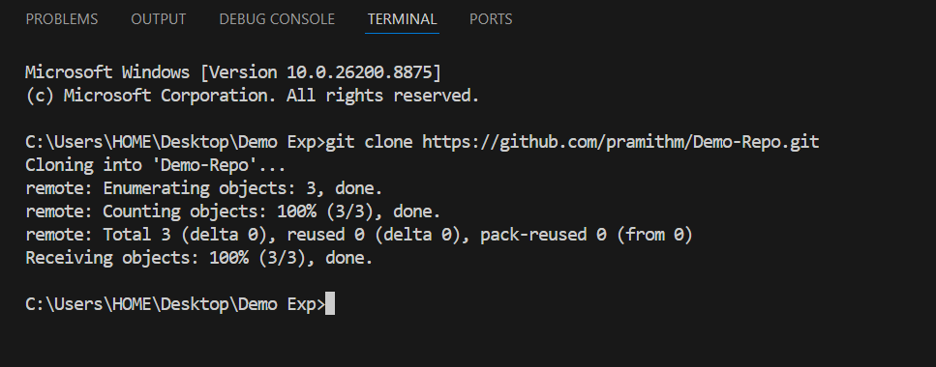
Step 3: Create a New Branch
git checkout -b feature-update

Verify the branch.
git branch
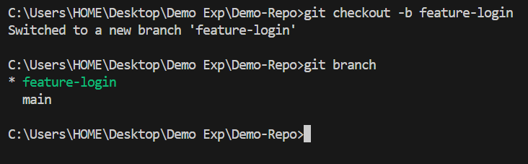
Step 4: Make Changes
- Open the project in Visual Studio Code.
- Modify a file (such as updating the README or adding a function).
- Save the changes.
Step 5: Check the Status
git status

Step 6: Stage the Changes
git add .

Step 7: Commit the Changes
git commit -m "Added new feature"

Step 8: Push the Branch
git push origin feature-update

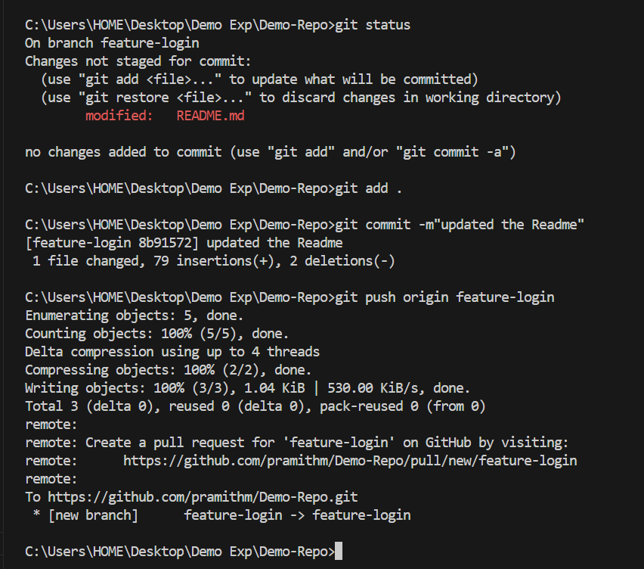
Step 9: Create a Pull Request
- Open your forked repository on GitHub.
- Click Compare & Pull Request.
- Enter a title and description.
- Click Create Pull Request.
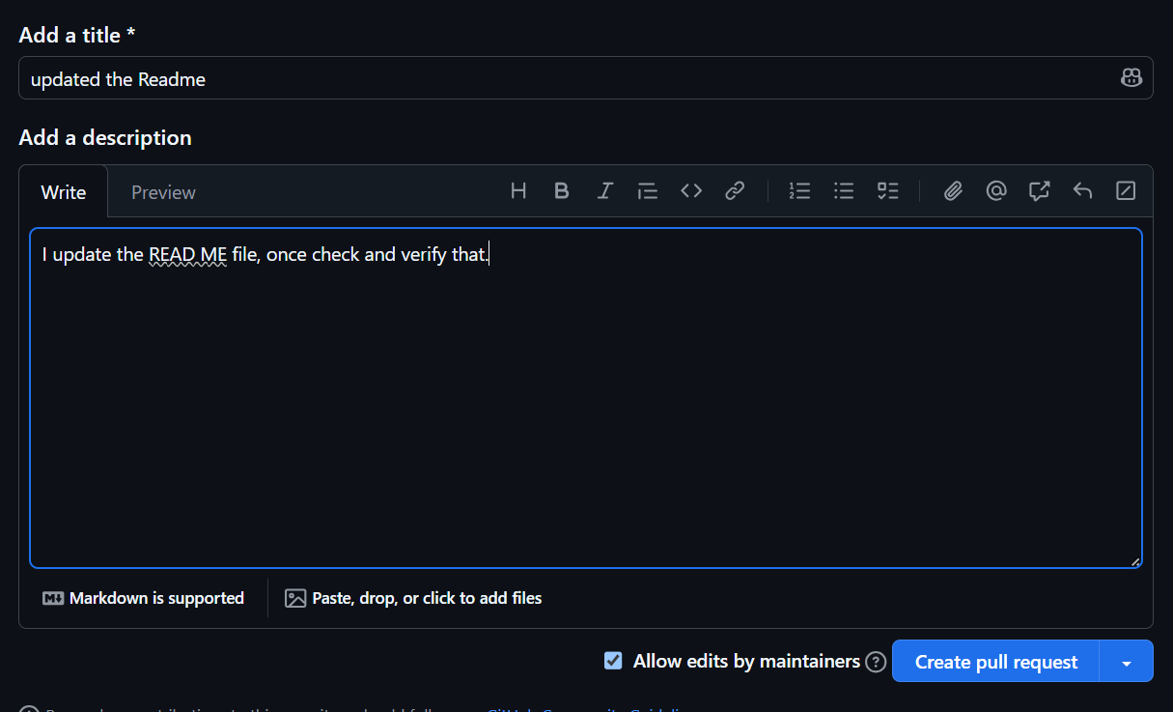
Step 10: Review the Pull Request
- Open the Pull Request.
- Review the code changes.
- Add comments or suggestions if required.
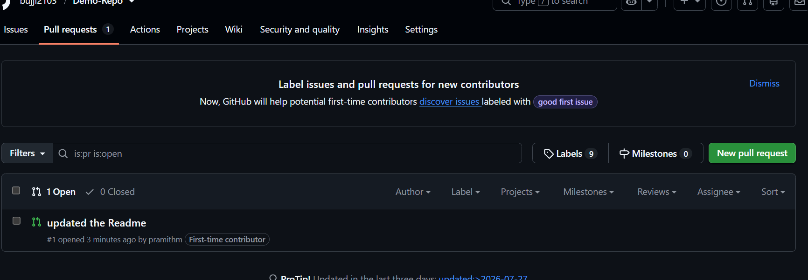
Step 11: Update the Pull Request
- Make the required changes.
- Commit the changes.
git add .
git commit -m "Updated based on review"
git push origin feature-update

The Pull Request will be updated automatically.
Step 12: Merge the Pull Request
- Click Merge Pull Request.
- Click Confirm Merge.
- Delete the feature branch if required.

Screenshots
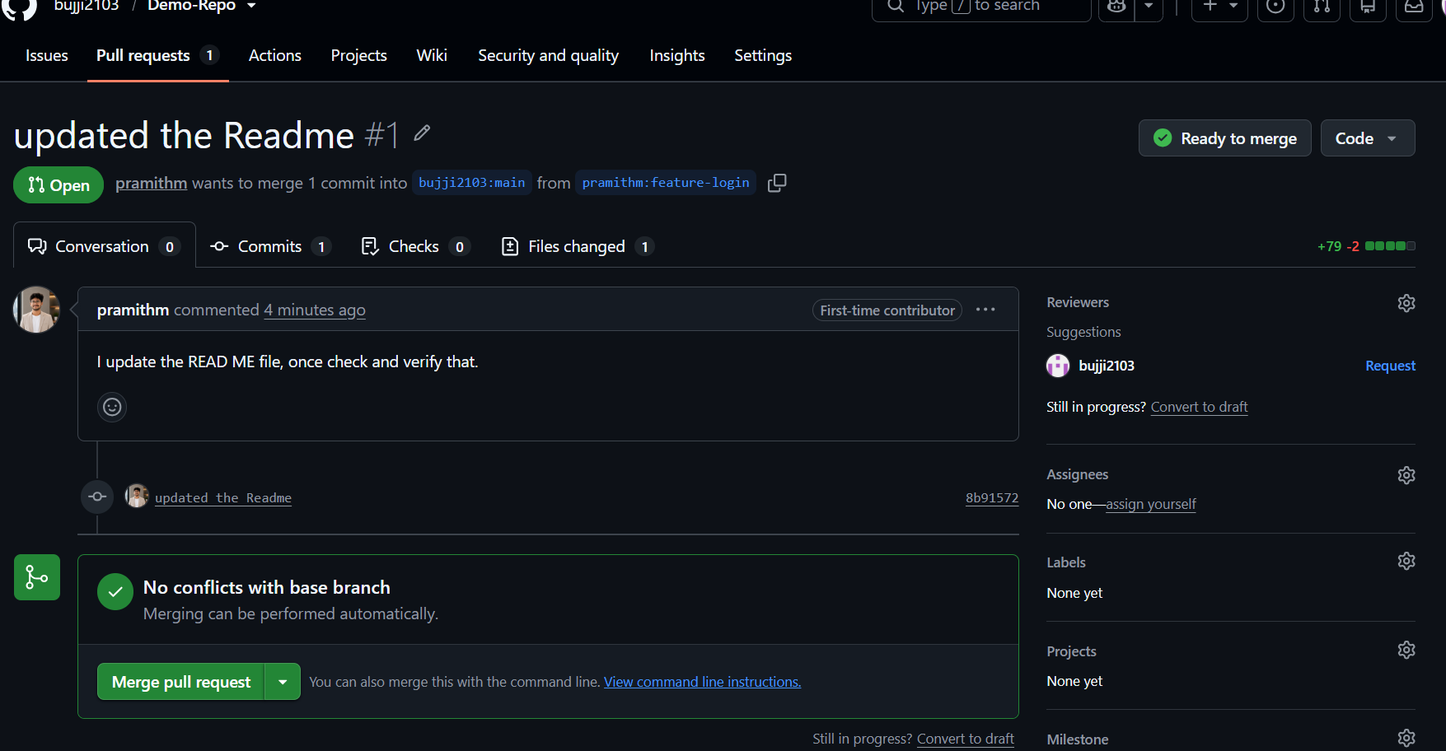

Observation
- The repository was forked successfully.
- A new feature branch was created.
- Changes were committed and pushed to GitHub.
- A Pull Request was created successfully.
- The Pull Request was reviewed and merged into the main branch.

Result
The Fork and Pull Request workflow was successfully performed. The changes were implemented in a feature branch, reviewed through a Pull Request, and merged into the main branch, demonstrating collaborative development using Git and GitHub.

